Mega Add-Ons Prime Video
1. Launch Details
Key Summary USP | Prime Video offers premium entertainment, including blockbuster movies, exclusive Amazon Originals, and popular global content. Customers can also stream select NBA matches and enjoy a variety of shows and films.  As part of the latest Mega Add-Ons launch, Prime Video is introduced as a new entertainment option. Customers can subscribe to the Viu streaming service through Mega Add-Ons at a special bundled monthly rate with a 12-month contract.
Channels | - CelcomDigi App  - MSA  - Pulse

2. Product Details
Offering Details:
Add-Ons | Prime Video
RRP | RM25.00
CD60SE – CD100 | RM13.00
CD120 & above | RM4.00
Contract Period | 12 months
Internet quota | 5GB High speed
Monthly Auto-renew | Yes
Validity | 30 Days
Monthly cycle | yes

This service is also available for subscription via StreamMORE / SpeedSTREAM.

3. Eligibility and Criteria
Eligibility & Criteria | - New subscriber (CelcomDigi Postpaid 60 SE and above)  - Existing subscriber (CelcomDigi Postpaid 60 and above)
Termination | - CelcomDigi Store only  Please inform the customer that an early termination penalty will apply. The penalty is calculated as: Recommended Retail Price (RRP) × the number of remaining contract months.

4. Customer Journey
Mega Add-ons Customer Journey | 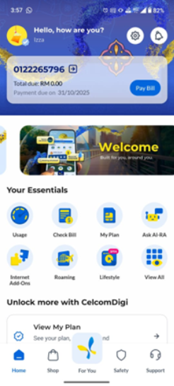 | 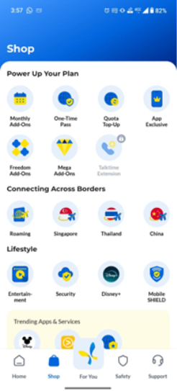 | 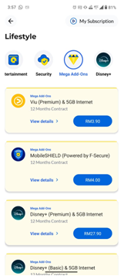
 | Step 1: In the CelcomDigi app, click Shop | Step 2: Click Mega Add-Ons | Step 3: All eligible Entertainment & Security offers will be listed here

5. Customer Communications (Active)
Active Comms | NA
FAQs | https://help.celcomdigi.com/en/support/solutions/articles/70000679852-faq-mega-add-ons-prime-video-with-celcomdigi-postpaid
Website | https://www.celcomdigi.com/postpaid/mega-add-ons

6. Internal Information
Visuals | 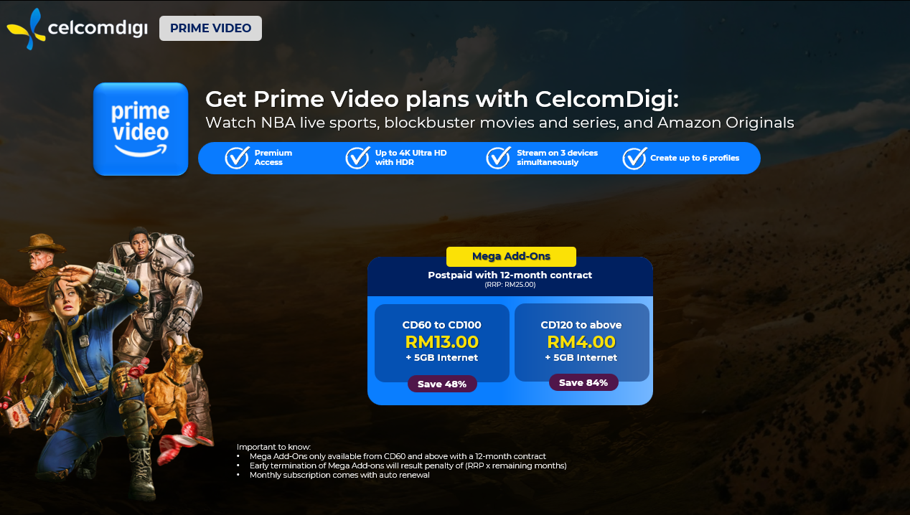
Internal FAQ | NA

7. Reference Guide (Agent Guide, Scenario Handling and Other References)
Reference Guide

8. Historical Communications (no longer active but retained for reference only)
Inactive Comms | NA
Inactive Customer Journey | NA

